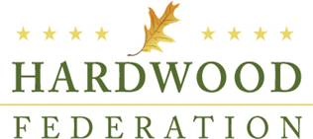

**Hardwood Federation**

**Requested Corporate Contribution FY 2015**

Corporate contributions to the Hardwood Federation support staffing and administrative services related to the Federation’s activities to support the U.S. hardwood industry through advocacy efforts in Washington, D.C., including educating Members of Congress, Administration Officials and Department and Agency Staff. Contributors are listed on the Federation’s website with links to their company sites.

If you would like to make a tax deductible contribution to our efforts, please provide the information below and return this form and your contribution to:

The Hardwood Federation

1101 K Street, NW, Suite 700

Washington, D.C. 20005

Company Name: _______________________________________________________

Company Contact: ______________________________________________________

Company Address: _____________________________________________________

_____________________________________________________

Company Website: _____________________________________________________

Contribution Amount: ____________________________________________________

*Thank you for your support!*

Dues, assessments and/or contributions to the Hardwood Federation are not deductible as a charitable contribution for income tax purposes.  However, payments may be tax deductible as an ordinary and necessary business expense subject to restrictions imposed with regard to "nondeductible" lobbying expenses.  In accordance with federal law, Hardwood Federation estimates that 18% for contributions will be non-deductible.