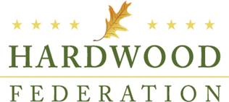

**Hardwood Federation**

**Fly-In 2024**

**May 21-23, 2024**

**Westin D.C. Downtown**

**Tentative Schedule**

**Tuesday, May 21**

HF Board Members and Young Leaders – Invite Only

12:00 – 1:00 p.m.

HF Board Meeting – Invite Only

Young Hardwood Leaders Meeting

1:30 – 4:00 p.m.

Welcome Reception

5:30 – 6:30

**Wednesday, May 22**

Hill Day Briefing & Breakfast

7:30 – 9:00 a.m.

Congressional Office Visits

10:00 a.m. – 5:30 p.m.

HFPAC Republican Reception

6:00 p.m. – 7:30 p.m.

HF Fly-In Dinner

7:30 p.m. – 9:00 p.m.

**Thursday, May 23**

HFPAC Democrat Reception

8:00 a.m. – 10:00 a.m.