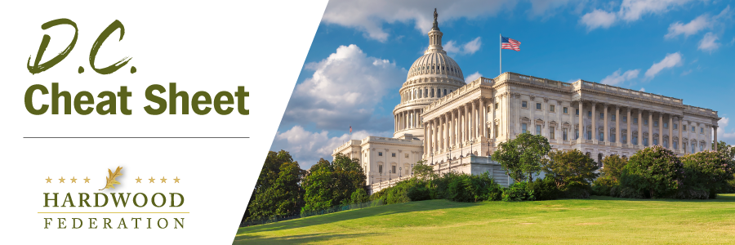

Quick Updates from Your HF Team

August Recess Memo – As Congress breaks for the August Recess through Labor Day, with the Senate out until September 5 and the House until September 12, be on the lookout for your federal lawmakers as they make the rounds in the states. In the event you see your elected officials, be sure to echo the Federation’s key “asks”:

- Hardwood Access and Education Program (HAP) – Establishing a hardwood education program, in the farm bill for example, kills two birds with one stone. It will help grow jobs in rural communities in my state and improve the environment.
- HAP - This program will give the industry much needed data to support sustainable forest management and the positive benefits of using wood products in home and workspaces and push back on false narratives. For details, click here.
- USDA Export Promotion - Downsizing USDA’s export promotion programs would impede our ability to export sustainably harvested hardwood products around the world and lead to customers choosing less sustainable and legally harvested alternatives.
- Taxes – Congress must make permanent 100% expensing of industrial equipment and the 20% deduction for small business. Congress should also restore full deductibility of business expenses. For details, click here.
- Transportation – Congress must pass a “supply chain package” that creates flexibility for truck weights, grows the dwindling pool of trucker drivers and expedites implementation of ocean shipping reforms. For details, click here.
USDA Offers Wildfire Defense Grants
On July 31, USDA Secretary Tom Vilsack announced that the USFS will accept applications for the Community Wildfire Defense Grant program, currently in its second year. This competitive grant program directly supports the USFS’s 10-year strategy to treat up to 20 million acres of national forests and grasslands and 30 million acres of other federal, state, Tribal and private lands to reduce wildfire risk. USFS will accept applications through October 31, 2023.

Congressional “To Do” List Stacks Up for September
When Congress returns in six weeks, they confront several major expiration dates for key federal programs, including the 2018 farm bill governing current USDA programs and the Fiscal Year (FY) 2024 budget. Both pieces of legislation will require short-term, stop-gap measures to prevent disruption of federal operations. While the fate of the funding bill remains uncertain, farm bill leaders are confident that USDA programs, including those that fall under the umbrella of the USFS, will continue on a business-as-usual basis even after expiration on September 30 of the current farm bill. Senate Agriculture Committee Chair Debbie Stabenow (D-MI) has stated that there is bipartisan consensus to pass a “continuing resolution” on the current law in the event Congress doesn’t close a deal by the deadline.

