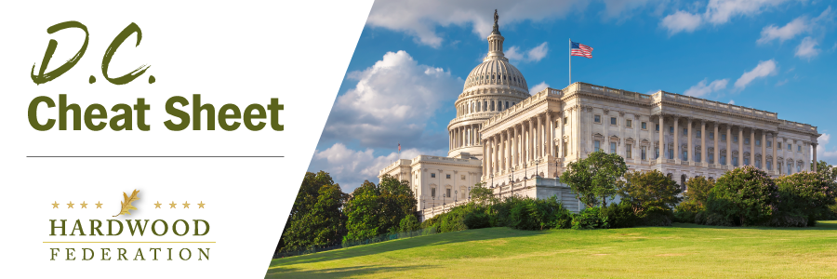
Quick Updates from Your HF Team

Register Today for Fly-In 2024!
May 21-23, 2024

Registration for the Hardwood Federation Fly-In is now open! Don’t delay make your reservations today! To make the most of your time on Capitol Hill we need you to register as soon as possible. Specially priced rooms at the Westin Downtown are available for Fly-In participants. Links to the reservation site are available as part of the reservation site below. Make plans TODAY to join us in Washington, D.C. May 21-23, 2024.
Sign up for the Fly-In and reserve your room HERE!
Events will kick off with a welcome reception on the evening of Tuesday, May 21 followed by a full day of meetings on the Hill with your Congressmen and Representatives…the Federation team will fully brief you over breakfast on key talking points and meeting logistics. We will host a PAC reception Wednesday night for our friends on the Republican side of the aisle and celebrate the day’s achievements over dinner. The Fly-in wraps up with a Thursday morning breakfast event recognizing the Democrats that support the hardwood industry.
Special Session for Young Leaders: Are you under 40? New to politics at the federal level? Interested in networking with your industry peers? Consider joining a special session for young industry leaders during the day on Tuesday, May 21. More information will be coming soon!
Check out the full schedule of events. The Federation has arranged for a limited number of rooms at a special rate at our host hotel, the Westin Downtown. Reserve yours today!
If you have a problem accessing the registration link above, please click here: Hardwood Federation Fly-In 2024 (regfox.com)

