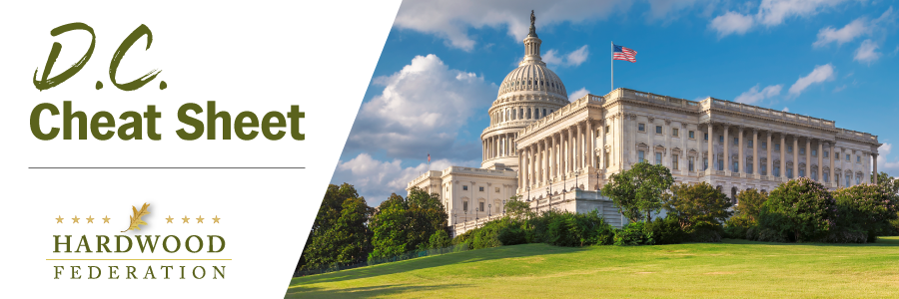

Quick Updates from Your HF Team

Senate Takes Aim at Red Tape Associated with Air Standards Review Process
On June 22, Senator Shelley Moore Capito (R-W.Va.) introduced the National Ambient Air Quality Standards Implementation Act of 2023 to modernize the air-quality standard setting process at EPA, including particulate matter (PM) associated with wood products facilities. The legislation would, among other things, require regulators to examine technological feasibility and economic impacts when issuing new standards and push back the statutory NAAQS review process from every five years to 10 years. The legislation compliments Federation comments submitted to EPA in late March, advocating against more stringent, proposed revisions to PM standards.
Manufacturers United on Tax Policy Front
Before breaking for the Independence Day Recess, manufacturers sent a statement to the House Budget Committee urging lawmakers to support tax policies that grow jobs and operations for small and medium sized manufacturers, including hardwood operations. Echoing support for the same priorities outlined by the hardwood industry, the letter advocates for making the small business deduction permanent, restoring 100% expensing of industrial equipment, and assuring that family-owned businesses can be passed down to the next generation by preserving estate tax flexibility. As Congress moves forward with its Fiscal Year (FY) 2024 budget, lawmakers will continue to move tax legislation to the front burner.

Independence Day Recess in Full Swing

With five days remaining for the congressional work period in the states, be on the lookout for federal lawmakers before they return to Washington next week. In the event you see your elected officials, be sure to echo the Federation’s key “asks” driven home during the June Fly-In. Members of Congress cannot hear these messages enough:

- Farm Bill – Congress must establish a grant program educating the public about the benefits of hardwood products, especially recognition of the carbon capture value of hardwood products.
- Transportation – Congress must pass a “supply chain package” that creates flexibility for truck weights, grows the dwindling pool of trucker drivers and expedites implementation of ocean shipping reforms.
- Taxes – As mentioned above, Congress must make permanent 100% expensing of industrial equipment and the 20% deduction for small business. Congress should also restore full deductibility of business expenses.

