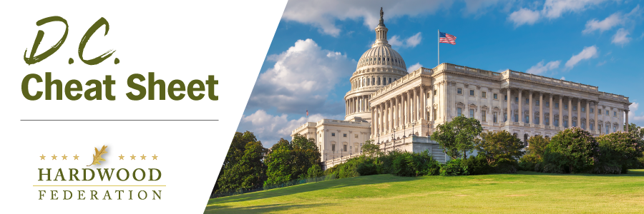
Quick Updates from Your HF Team
Wood Products Group Lobbies Appropriators for Carbon Study
On May 8, the Federation and its partners in the Wood Products Coalition turned to annual appropriations, the legislative vehicles that fund the federal government, to promote a USDA study that will quantify the amount of carbon stored in wood products. Industry pointed out to House and Senate appropriations staff from both parties that the Forest Products Laboratory (FPL) already specializes in researching wood products and their applications and is therefore well suited to break down the amount of carbon stored annually in finished goods. Annual increases in the amount of carbon stored in wood products could then be measured, and their ability to mitigate a changing climate quantified, thereby assuring that industry would be rewarded rather than penalized in climate programs. Stay tuned for updates on the study’s progress as the slog to hammer out a Fiscal Year (FY) 2024 budget continues.
Federation Fly-In Coming Up
With the June 13-15 Fly-In just five weeks away, the industry agenda is rapidly taking shape. House Agriculture Committee Chair and longtime hardwood champion GT Thompson (R-PA) will be the Federation's special dinner speaker on Wednesday, June 14 at the Capitol Hill Club. The HF Team is also working on a special guest for our opening reception on Tuesday night, so stay tuned! More than 50 of your industry colleagues are already registered to join us in June... don't miss out! Be sure to register for the meeting and book your room, with our special rate, today! Hotel registration has been extended to May 16, but won't be extended further, so act now!

House Lawmakers Spotlight Trucking Challenges
On May 10, the House Subcommittee on Highways and Transit conducted a hearing highlighting strains on the nation’s trucking system, which transports 76% of the dollar value of U.S. freight. Subcommittee Chairman Rick Crawford (R-AR) opened the session by highlighting the acute trucker shortage, pointing out that the industry will need 1.2 million new drivers over the next several years to keep up with demand and trucker retirements. Thursday’s session will help lay the groundwork for an expected “supply chain package,” which may include the industry-supported “Safer Highways and Increased Performance for Interstate Trucking (SHIP IT) Act” and “Ocean Shipping Implementation Act,” among other vehicles.
Mark Your Calendar! The Federation Fly-In is Back, June 13 – 15, 2023
To sign up and reserve your room, please click HERE!

